# INTRODUCTION

## About the Company

Intelecare is an outsourcing company that is located in Bacoor, Cavite. The said company started out small but through the years their numbers had grown. With their growth, the need of expanding and upgrading their facilities is a must. The reason for this is to improve their work force so that they exceed the expectations of their clients.

The company is planning to set up a new site, also located in Bacoor, Cavite, where they will be putting up more computers for them to use.

With this, I am proposing a project where it involves the installation of Linux (Ubuntu) operating system on these computers. This project will also include the creation of user accounts for each administration and department personnel and the configuration of the computer’s policy settings.

## Products

Intelecare is a company that offers quality back office and outsourcing services for an agreeable price. They currently have multiple local and global accounts – from small scale businesses to elite ones such as AT&T, Blackberry, Microsoft and more. They are one of the pioneering BPO companies here in Cavite.

## History

The company was started by Terra Branford. Eyeing to be one of the first BPO companies in Cavite, she first built the company with a hundred computers with some local accounts. As the years pass by, the company had fared well due their dedication, hard work and strong conviction. As a result, the company now is one of the best in their line of field here in the country. Since then, they had started taking on international accounts and had gained international recognition.

## Departments

#### Administration

|  |  |
| --- | --- |
| Name | User Account |
| Terra Branford | terraff6 |
| Locke Cole | lockeff6 |
| Celes Chere | celesff6 |

#### Finance and Human Resource

|  |  |
| --- | --- |
| Name | User Account |
| Yuffie Kasaragi | yuffieff7 |
| Tifa Lockhart | tifaff7 |
| Vincent Valentine | vincentff7 |

#### Production and Man Power

|  |  |
| --- | --- |
| Name | User Account |
| Cloud Strife | cloudff7 |
| Squall Leonhart | squallff8 |
| Zidane Tribal | zidaneff9 |

## Achievements

* Top 100 Asian Companies of 2012, (Rank: 25)
* Top 10 Most Promising Companies in the Philippines 2012, (Rank: 3)
* Global Companies Expo 2012’s Best Newcomer Award

## Objectives

* To successfully install Ubuntu operating system on computers
* To create users and groups for each administration and department personnel
* To set-up the computer’s basic policy settings
* To create files and directories using Linux
* To show common Linux commands
* To discuss about the use of the text editor, the desktop environment and the web browser in Linux
* To show the process of troubleshooting in Linux on simple errors

# INSTALLATION OF LINUX

## Hardware Requirements

* Intel or AMD x86 processor
* 20GB Hard Disk Drive
* 1024 MB RAM

## Installation Process of Linux (Ubuntu)

On this screen, select “Install Ubuntu” to proceed with the installation.

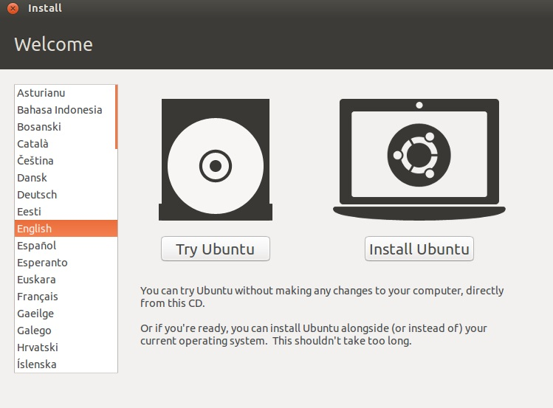

Select “Install this third-party software” and click Continue.

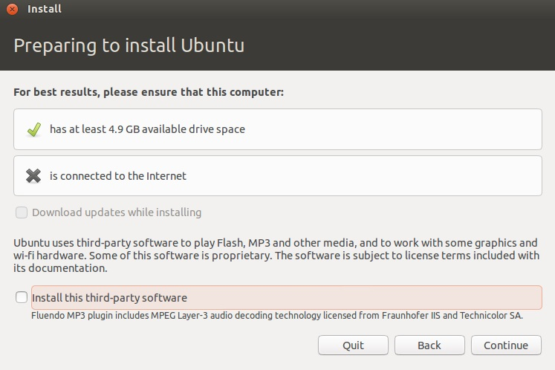

Select “Install Ubuntu 12.10 alongside Ubuntu 12.10” and click Continue.

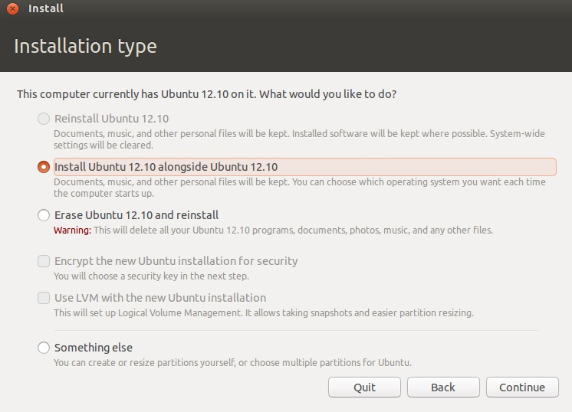

Just wait up for the setup to finish. You can also indicate your location in this screen.

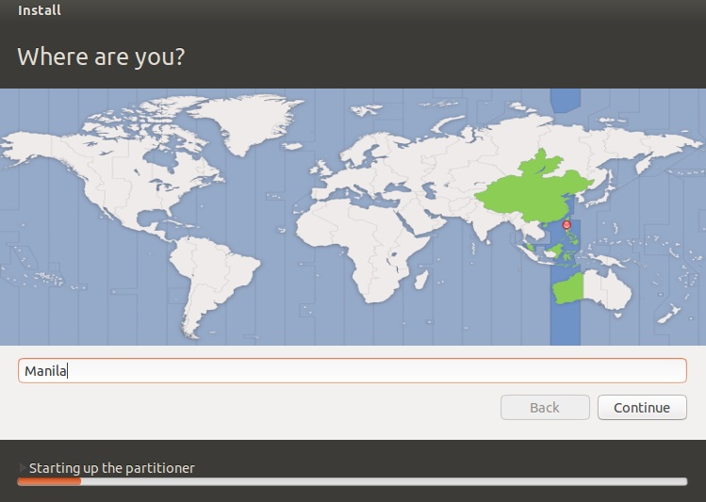

Select the type of keyboard you are using and click Continue to head on to the next screen.

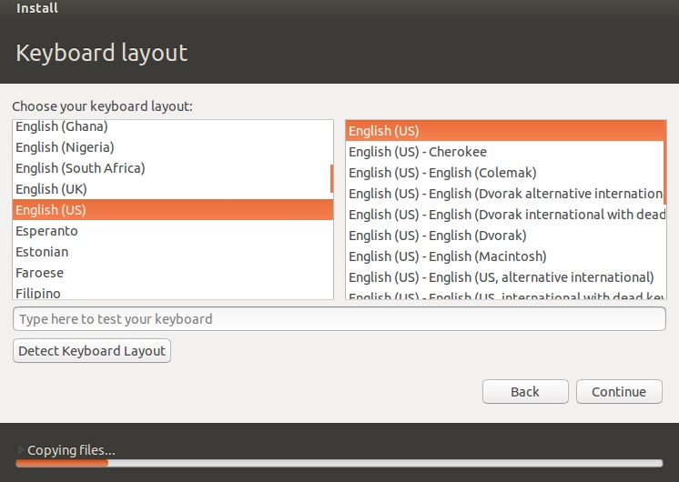

You can personalize your computer as well as set up an account on this screen. Click Continue to proceed.

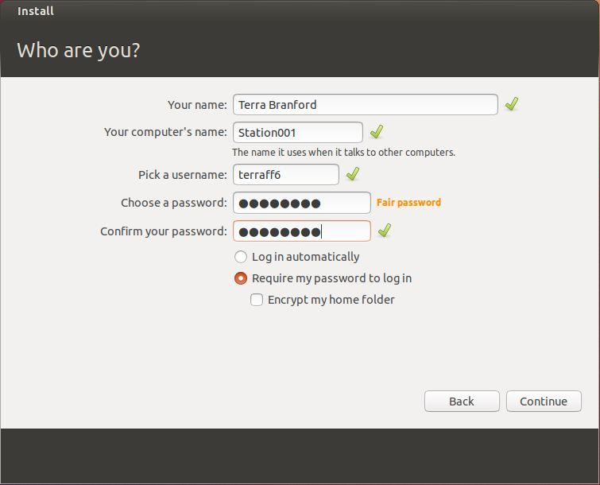

Just wait for the setup to complete.

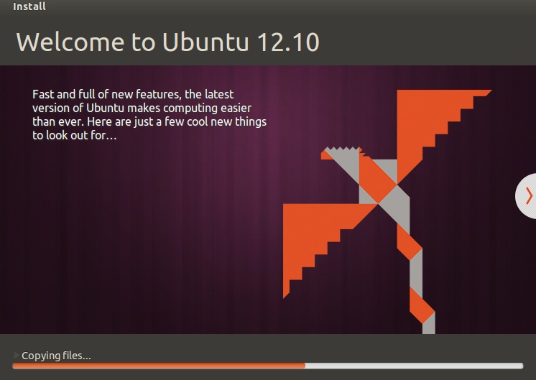

After the completion of the installation, it will prompt you to restart your computer.

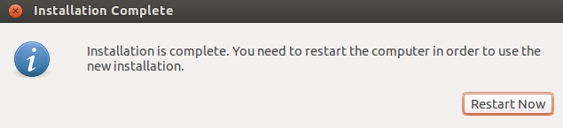

Once done on restarting your computer, it will lead you to the login screen. After successfully logging in, you can see your Ubuntu desktop.

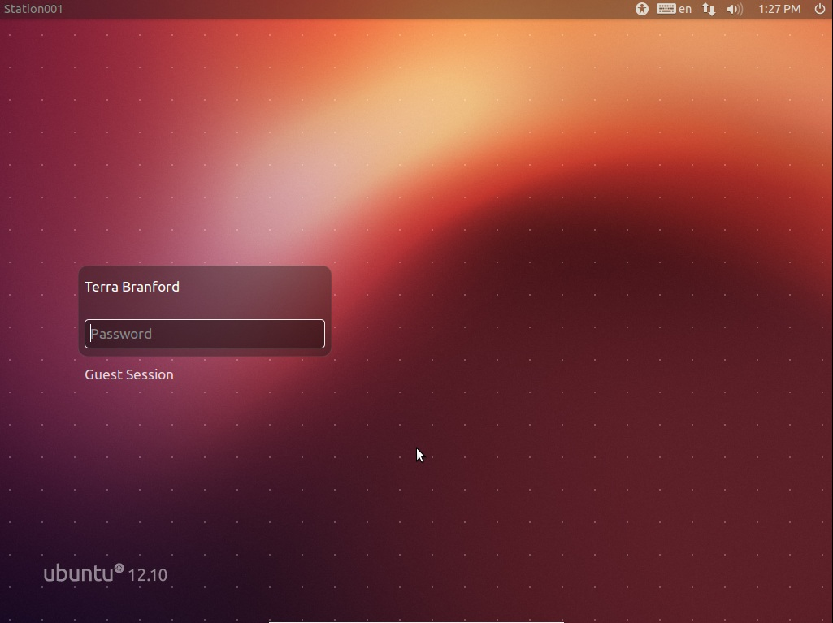

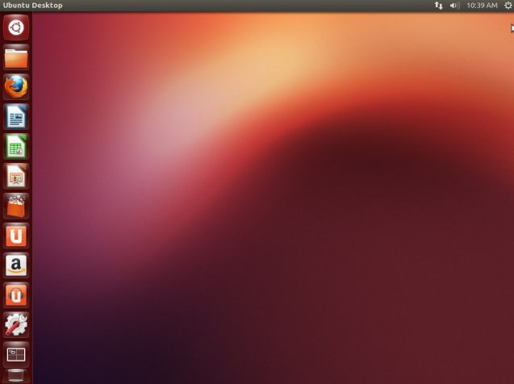

## Post-Installation Issues

Upon installation, you need to update your operating systems so that it can have the latest versions of utilities/operating system for better performance. This can be done by using the command “sudo apt-get update”, which is used to update the download links, and “sudo apt-get upgrade”, which is used to upgrade your operating system o its latest version.

## GRUB



GRUB or Grand Unified Bootloader is a boot loader package, created from the GNU Project, which allows the user the choice to boot one of multiple operating systems installed on a computer or select a specific kernel configuration available on a particular operating system's partitions.

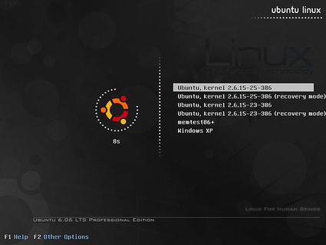

The picture above is a sample of GRUB upon startup of a system that has multiple configurations and operating systems installed.

# CREATING USERS AND GROUPS

## Creating Users

To create a new user account, you must log in into the “sudoer” or Administrator account. After logging in, key in the command “adduser”. The syntax for this command is “sudo adduser <username>”. After typing the command, hit the Enter key. It will ask you for the account password and some additional information for the newly created account. After entering the password and the additional information, it will ask you if the information you entered is correct and the account is good to go.

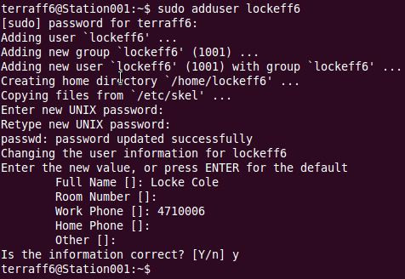

In this example above, the command was used to create Locke Cole’s user account. For the other personnel’s accounts, we use this code to make them.

|  |  |
| --- | --- |
| Personnel | Command |
| Celes Chere | sudo adduser celesff6 |
| Yuffie Kasaragi | sudo adduser yuffieff7 |
| Tifa Lockhart | sudo adduser tifaff7 |
| Vincent Valentine | sudo adduser vincentff7 |
| Cloud Strife | sudo adduser cloudff7 |
| Squall Leonhart | sudo adduser squallff8 |
| Zidane Tribal | sudo adduser zidaneff9 |

## Creating Groups

To create a new group, you must log in into the “sudoer” or Administrator account. After logging in, key in the command “addgroup”. The syntax for this command is “sudo addgroup <group name>”. After typing the command, hit the Enter key and the group is good to go.

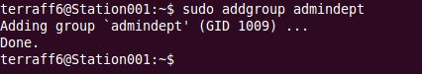

In this example above, the command was used to create the Administration group. For the other groups, we use this code to make them.

|  |  |
| --- | --- |
| Personnel | Command |
| Finance and Human Resource | sudo addgroup finhrdept |
| Production and Man Power | sudo addgroup prompdept |

## Adding Users to a Group

To create a user to a group, you must log in into the “sudoer” or Administrator account. After logging in, key in the command “addgroup”. The syntax for this command is “sudo addgroup <username> <groupname>”. After typing the command, hit the Enter key and the user will be added to the group.

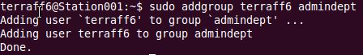

In this example above, the command was used to put Terra Branford’s account to the Administration group. For putting the other accounts to other groups, we use this codes to assign them.

|  |  |
| --- | --- |
| Personnel | Command |
| Locke Cole | sudo addgroup lockeff6 admindept |
| Celes Chere | sudo addgroup celesff6 admindept |
| Yuffie Kasaragi | sudo addgroup yuffieff7 finhrdept |
| Tifa Lockhart | sudo addgroup tifaff7 finhrdept |
| Vincent Valentine | sudo addgroup vincentff7 finhrdept |
| Cloud Strife | sudo addgroup cloudff7 finhrdept |
| Squall Leonhart | sudo addgroup squallff8 finhrdept |
| Zidane Tribal | sudo addgroup zidaneff9 finhrdept |

# CREATING/DELETING FILES AND DIRECTORIES

## Creating Files and Directories

To create directories or folders, we use the command “mkdir”. You don’t need to log on the sudoer account to create a directory. The syntax for this command is “mkdir <directory name>”.

To create files, we use the command “touch”. You don’t need to log on the sudoer account to create a file. The syntax for this command is “touch <file name>”.

In the example below, mkdir was used to create three directories and touch was used to create a file. By using the command “ls”, we can be able to see the created directories and files. As you can notice, directories or folders are colored ***blue*** while files are ***white***.

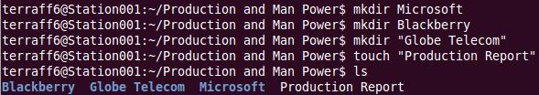

## Deleting Files and Directories

To delete directories or folders, we use the command “rmdir”. You don’t need to log on the sudoer account to delete a directory. The syntax for this command is “rmdir <directory name>”.

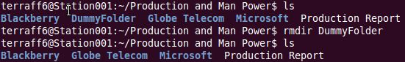

To delete files, we use the command “rm”. You don’t need to log on the sudoer account to delete a file. The syntax for this command is “touch <file name>”.

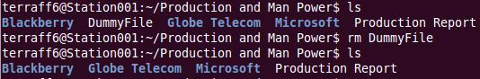

# COMMON LINUX COMMANDS

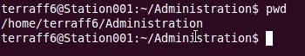

Code: pwd

Use: Shows present working directory

Syntax: pwd

cd.JPGCode: cd

Use: Changes directory

Syntax: cd <new directory path>

cd ...JPGCode: cd ..

Use: Returns to previous directory

Syntax: cd ..

Code: cp

Use: Copies file or directory on specified location

Syntax: cp <path of file> <path to the location where you want to copy the file>

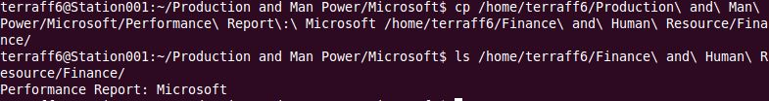

Code: ls –al

Use: Show file/directory permissions, group, owner and other info

Syntax: ls –al

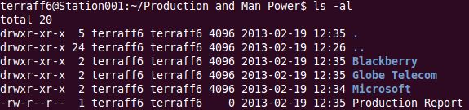

Code: mv

Use: Moves/Renames a file or directory

Syntax: mv <path to file> <path to the location where you want to move the file/directory>

mv <path to file> <path to the same location, include new name>

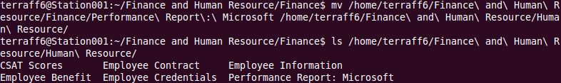

# CONFIGURING POLICY SETTINGS ON USERS AND GROUPS

## Policy Settings and How it Works

Policy settings are used to control the access among files or directories by the user (u), by its group (g) and by other users (o). Permissions are symbolized by “r” for read, “w” for write and “x” for executable.

The syntax for the permissions is “drwxrwxrwx”. The first character of the ten-character can be either a dash (“-“) or the letter “d”. A dash (“-“) tells us the item is a file while the letter “d” represents directories. The following sets of “rwx” is represents the permission of the user, group and others user.

For example, the permissions “-rwxrw-r--“ tells us that user can read the file, wirte on it and execute it (rwx). The group can only read and write (rw-) while the other users can only read it (r--).

## Viewing and Configuring Policy Settings

Using the code “ls -al” lets us view the permissions of the files/directories. We can also use “ls -al <filename> to view the permission of a specific file/directory.

We use the code “chmod” to change the permission of a file/directory. First, declare where you are going to change the permission. Specify if it’s on the part of the user, group or others users by using “u”, “g” or “o”. If you are going to add a permission, use “+”. To remove a permission, we use “-“. Then, we indicate the permission we will modify (r” for read, “w” for write and “x” for executable). Finally, we put the file/directory name at the end.

For example, the command “chmod ugo+rwx List” gives the permission to read, write and execute to the user, group and others to the file “List”. We could also do it separately. The code “chmod g+r o-w List” gives the group the permission to read while restricting other users to write on the file.

## Files’ and Directories’ Policy Setting

#### Administration

**Folder**: Administration (“drwxr--r--“)

**Sub-Folder**: Microsoft (“drwxr--r--“)

**Files**: Proposal (“-rwxr--r--“)

Account Contract (“-rwxr--r--“)

Account Info (“-rwxr--r--“)

Financial Report (“-rwxrw-r--“)

Production Report (“-rwxrw-r--“)

**Sub-Folder**: Blackberry (“drwxr--r--“)

**Files**: Proposal (“-rwxr--r--“)

Account Contract (“-rwxr--r--“)

Account Info (“-rwxr--r--“)

Financial Report (“-rwxrw-r--“)

Production Report (“-rwxrw-r--“)

CSAT Scores (“-rwxrw-r--“)

**Sub-Folder**: Globe Telecom (“drwxr--r--“)

**Files**: Proposal (“-rwxr--r--“)

Account Contract (“-rwxr--r--“)

Account Info (“-rwxr--r--“)

Financial Report (“-rwxrw-r--“)

Production Report (“-rwxrw-r--“)

CSAT Scores (“-rwxrw-r--“)

#### Finance and Human Resource

**Folder**: Finance and Human Resource (“drwxr--r--“)

**Sub-Folder**: Human Resource (“drwxr--r--“)

**Files**: Employee Information (“-rwxr--r--“)

Employee Credentials (“-rwxr--r--“)

Employee Contract (“-rwxr--r--“)

Employee Benefits (“-rwxr--r--“)

Performance Report: Microsoft (“-rwxrw-r--“)

Performance Report: Blackberry (“-rwxrw-r--“)

Performance Report: Globe Telecom (“-rwxrw-r--“)

CSAT Scores (“-rwxrw-r--“)

**Sub-Folder**: Finance (“drwxr--r--“)

**Files**: Employee Attendance (“-rwxrw-r--“)

Payrolls (“-rwxr--r--“)

Employee Taxes Info (“-rwxr--r--“)

Company Taxes Info (“-rwxr--r--“)

Financial Report (“-rwxrw-r--“)

#### Production and Man Power

**Folder**: Production and Man Power (“drwxr--r--“)

**Files**: Production Report (“-rwxrw-r--“)

**Sub-Folder**: Microsoft (“drwxr--r--“)

**Files**: Employee Attendance (“-rwxrw-r--“)

Daily Report (“-rwxr--r--“)

Weekly Report (“-rwxr--r--“)

Performance Report: Microsoft (“-rwxrw-r--“)

**Sub-Folder**: Blackberry (“drwxr--r--“)

**Files**: Employee Attendance (“-rwxrw-r--“)

Daily Report (“-rwxr--r--“)

Weekly Report (“-rwxr--r--“)

CSAT Scores (“-rwxrw-r--“)

Performance Report: Blackberry (“-rwxrw-r--“)

**Sub-Folder**: Globe Telecom (“drwxr--r--“)

**Files**: Employee Attendance (“-rwxrw-r--“)

Daily Report (“-rwxr--r--“)

Weekly Report (“-rwxr--r--“)

CSAT Scores (“-rwxrw-r--“)

Performance Report: Globe Telecom (“-rwxrw-r--“)

On setting the permissions of file/directories, we use this commands on the sudoer account.

|  |  |
| --- | --- |
| Policy Setting | Command |
| rwxr--r-- | sudo chmod go-wx <file/directory name>  sudo chmod 744 <file/directory name> |
| rwxrw-r-- | sudo chmod g-x o-wx <file/directory name>  sudo chmod 764 <file/directory name> |
| r--r--r-- | sudo chmod ugo-wx <file/directory name>  sudo chmod 444 <file/directory name> |
| rw-rw-rw- | sudo chmod ugo-x <file/directory name>  sudo chmod 666 <file/directory name> |
| rwxrwxrwx | sudo chmod ugo+rwx <file/directory name>  sudo chmod 777 <file/directory name> |

# TEXT EDITOR

To access and add text to a file, we use the code “vi <filename>”. In some versions of Linux or upgraded versions of Ubuntu, using the code “vim <filename>” creates a file and will automatically lets you add a text into a file.

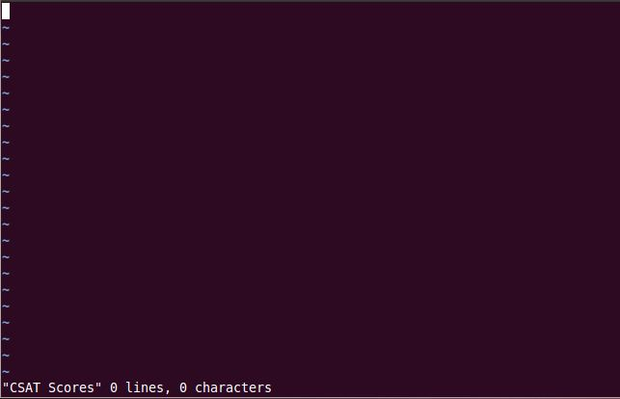

While editing using “vi” or “vim”, we press the ‘a’-key on “vi” and ‘I’-key on “vim” to insert text into the file. Pressing the ‘Esc’-key will exit you from entering text to the file. After pressing the ‘Esc’-key, using the command “:q!” will quit text editor mode without saving it. Use the command “:wq!” to quit and save your work.

To view the contents of a file, the “less <filename>” command is used.

# WEB BROWSER

Mozilla Firefox is the default web browser on Linux upon installation.



Mozilla Firefox is a web browser developed for Windows, OS X and Linux by the Mozilla Corporation and Mozilla Foundation. Unlike on Windows, Mozilla supports 32-bit and 64-bit on Linux. It is very easy to use and requires no special skill on using it.

# DESKTOP ENVIRONMENT

## X Windows Desktop Environment: GNOME

GNOME is a graphical user interfaced for the operating system created by Red Hat employees. It is composed mostly by free and open source software. GNOME basically offers different default applications that allow its user to freely change their workspace.



#### Changing the Desktop Background

Right click on your Desktop and select “Change Desktop Background”. You may choose a preset design or add an image of your choice. Close after confirming/saving your work.

## OpenOffice

OpenOffice is the default office program for Linux operating systems.

It is an open-source office productivity software compilation, descended from OpenOffice.org.

Like Microsoft’s Office Suite, OpenOffice contains:

* a word processor known as Writer,
* a spreadsheet known as Calc,
* a presentation application known as Impress,
* a drawing application known as Draw,
* a formula editor known as Math and
* a database management application known as Base

While its default file format is OpenDocument Format (ODF), OpenOffice can read a wide variety of other formats such as those from Microsoft Office.

# TROUBLESHOOTING LINUX

## File “not found” or “does not exist”

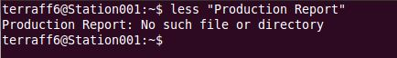

Make sure that you are in the right directory of the file you are trying to access. You can check it by using “pwd” or “ls”.

## Cannot Add New User or Group

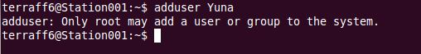

Only the sudoer account may add new users and groups to the system. If you are logged on the sudoer account, make sure to include “sudo” on the start of your command.

## Inserting Text on Text Editor



Press “a” or “I” while inside “vi” or “vim” before entering any text.

# REFERENCES

http://en.wikipedia.org/wiki/Linux

http://en.wikipedia.org/wiki/Ubuntu_(operating_system)

http://en.wikipedia.org/wiki/GNU_GRUB

http://en.wikipedia.org/wiki/GNOME

http://en.wikipedia.org/wiki/OpenOffice